Isaac Asimov’s Magical Worlds of Fantasy, Witches and Wizards, Two volumes in One. Bonanza Books 1985 First Edition not stated, full print line, VG dust jacket taped to cover, Xlibris with library stamps only on inside of front and back covers and on title page. VG Hardback with all 649 pages tight and unmarked. More photos on request; 8vo 8" - 9" tall ISBN 051747669X
ISBN not recognized by AbeBooks
ID 000081 Price $15 Box 20 or 21
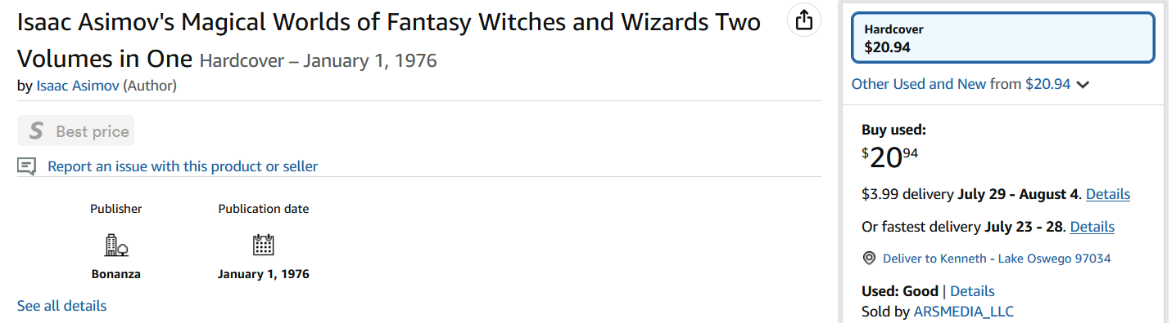
Amazon
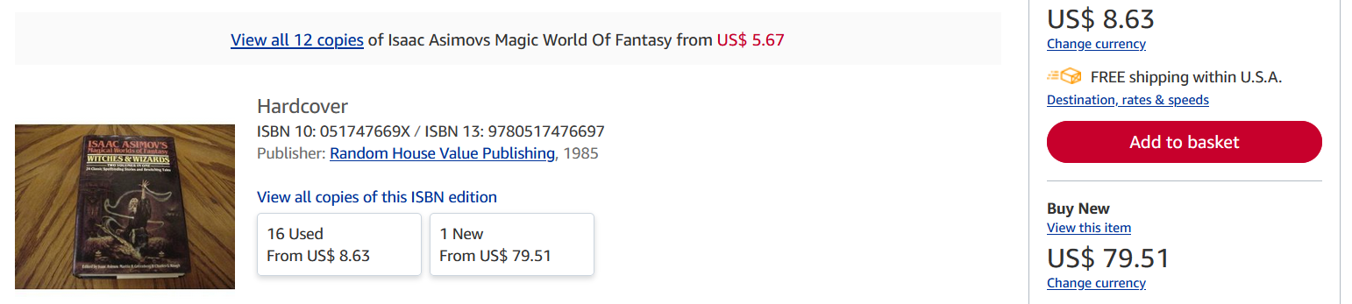
AbeBooks, New $79.51, low $8.00 to $30
BookFinder 75 copies $8.35 to $30 to $114
BookScouter $5.06 on ebay

